X00101556, X00131787

ITT: Dublin, Year 2 Project

C&C HPMS – User Manual

Table of Contents

Introduction 1

First Entering the System 2

Logging In 2

Consultant and Admin Functionality 3

Adding a Patient to the System 3

View Patients in the System 4

Assigning a Consultant to a Patient 5

Admin 5

Consultant 6

Making an Appointment for a Patient 7

Viewing an Appointment 8

Rescheduling an Appointment 9

Unique Consultant Functionality 10

Declaring / Updating your Specialisation 10

Adding a Prescription to a Patient 11

Removing a Prescription from a Patient 12

Admitting a Patient to a Ward 13

Discharging a Patient 14

Completing / Cancelling Appointments 15

View Historical Appointments 16

Unique Admin Functionality 17

Viewing the Activity Log 17

Edit Patient Information 18

Generate / Pay Patient Bill 19

Remove a Consultant from a Patient 20

Chief Admin Unique Functionality 21

Adding a New User 21

Editing a User 22

Adding new Medication 23

Editing / Deleting Medication 24

Adding a New Ward 25

Editing a Ward 26

Add New Equipment 27

Edit Equipment 28

# Introduction



Figure 1- C&C HPMS Logo

Welcome to the User Manual for the C&C Hospital Patient Management System. This guide will be split up into five parts. These being;

1. First Entering the System
2. Consultant and Admin Functionality
3. Unique Consultant Functionality
4. Unique Admin Functionality
5. Unique Chief Admin Functionality

Each section having many sub-sections going over exactly how to navigate around the website and work its individual components. Please refer to the table of contents to find the location of the answer to the question you have about the system.

# First Entering the System

## Logging In

After receiving your credentials to log-in from the Chief Admin of the system. These credentials being your Email and Password. Access the login page of the system and you should be greeted with this screen.

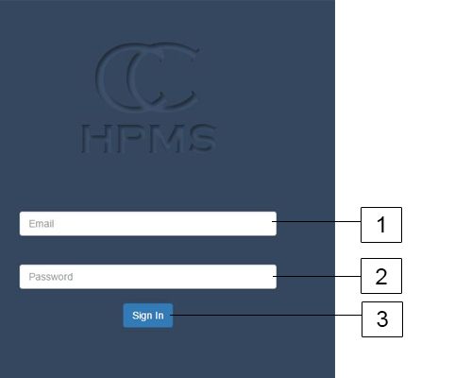

Figure 2- Login Screen

1. Enter email assigned to you.
2. Enter password assigned to you.
3. Hit “Sign In” button.

After following these steps, you should be greeted by a welcome page to your role in the hospital whether that is Consultant or Admin. If you are greeted with an error message saying your password or email is wrong double check your credentials are correct. If you are still having issues get in contact with the Chief Admin of your hospital to have them reset your password for you.

# Consultant and Admin Functionality

## Adding a Patient to the System

To admit a patient to the system first make sure you are logged into the system with credentials that are associated with either a Consultant or Admin. Next look over to the navigation bar to the left side of the screen and identify the “Patients” tab. (Note: Navigation bar may look slightly different depending if you are logged in as an Admin or a Consultant.)

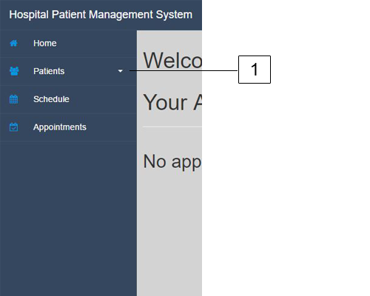

Figure 3 - Navigation Bar

1. Clicking on the Patient tab will drop down this menu.

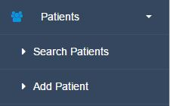

Figure 4 - Navigation Bar Clicked

Clicking on Add Patient will bring you to the appropriate page.

Once all form fields have been filled in hit the “Add Patient button” at the bottom of the form. If all information is entered correctly a message will be shown saying the patient has been added successfully. Otherwise an error message will be displayed telling you what is wrong with the patient information.

## View Patients in the System

To view all patients in the system, locate the “Patients” tab that is in the left side navigation bar. For a more detailed picture of this refer to the “Adding a Patient to the System” section of this User Manual. Once the “Patients” tab is clicked it will expand and the option “Search Patients” will be available. Click this to be brought to the appropriate page. (Note: Page might look slightly different whether accessing as an admin or consultant.)

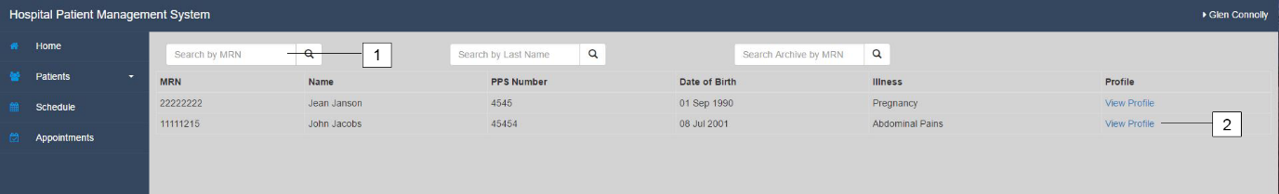

Figure 5 - Search Patient

1. Using the three search bars at the top you can either search for a specific patient with their medical record number (MRN), Last Name or you can search the archive of patients again with a specific MRN.
2. Clicking on View Profile will bring you to that specific patient’s profile page. Which has further functionality for that patient and full list of information.

## Assigning a Consultant to a Patient

This can be done in two ways depending if you are logged in as an admin or a consultant.

### Admin

If you are logged in as an admin you can assign anyone of the consultants in the system to a new patient. To do this first go to the profile of the patient you would like to assign a consultant to. If you are unsure how to do this look at the “View Patients in the System” section of this manual.

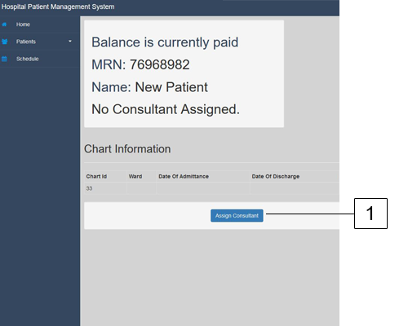

Figure 6 - Assign Consultant (Admin)

1. Click assign consultant once on desired patient page.
2. Once the list of consultants appears choose a consultant by clicking “Add Consultant”.

### Consultant

While logged in as a consultant navigate to the profile of the patient you would like to assign a consultant to. Once there;

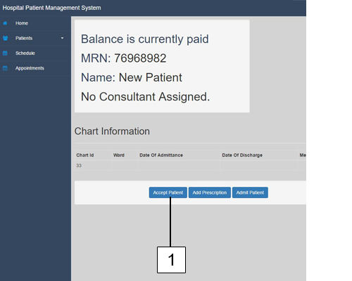

Figure 7 - Assign Consultant (Consultant)

1. Simply click the “Accept Patient” button to be assigned that patient.

## Making an Appointment for a Patient

Making an appointment for a patient is done through that specific patient’s profile page. If you do not know how to do this look for the “View Patients in System” section of this manual.

Before Appointments can be made a consultant must be assigned to a patient.

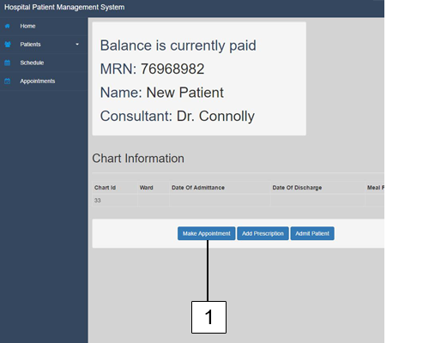

Figure 8 - Make Appointment Button

1. Click the Make Appointment button.

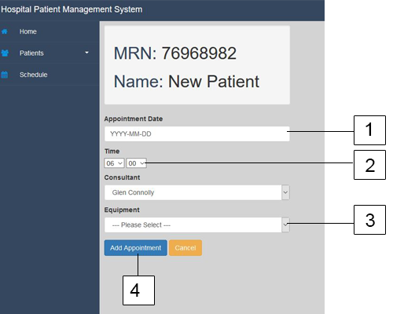

Figure 9- Make Appointment Page

1. Enter date of appointment must be formatted like this “2017-01-01”.
2. Select a time, left side box is hours’ right side box is minutes.
3. Select the equipment they will be using from the dropdown menu.
4. Click the Add Appointment button.

## Viewing an Appointment

Can be done in two ways for consultants and a single way for admins. Both consultants and admins have access to the “Schedule” page that can be accessed in the left side navigation bar.

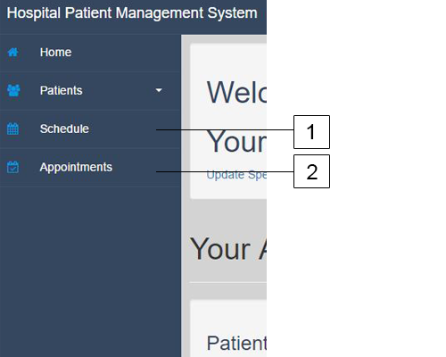

Figure 10 - View Appointment Navigation

1. Schedule will bring up a full calendar that will have all appointments displayed. For consultants only appointments that are assigned to you will show up and admins will have a view of all appointments.
2. (Only available to consultants) Clicking this will bring you to a full list of appointments that are assigned to you. Clicking on the “View Appointment” button will bring you to a full description of that appointment.

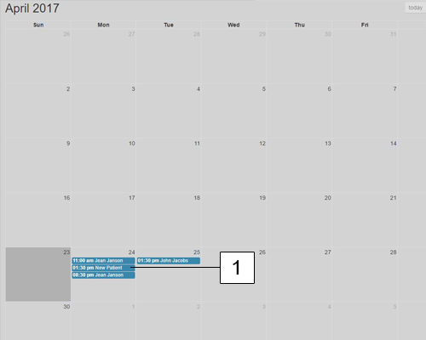

Figure 11- View Schedule Page

1. Clicking an appointment on the “Schedule” page will bring you to the full appointment information page.

## Rescheduling an Appointment

This is done through the main appointment page which can be accessed through the Schedule page or the Appointment page. If you are unsure on how to get to a specific appointment page look at the “Viewing an Appointment” section of this manual.

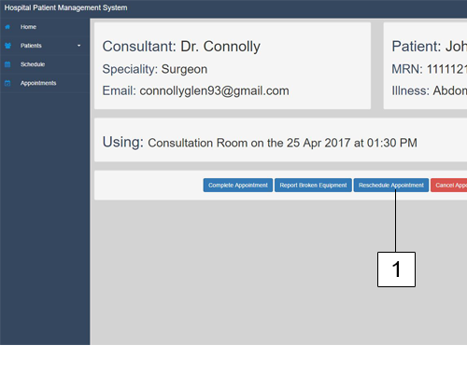

Figure 12 - Main Appointment Page

1. Clicking the “Reschedule Appointment” button on the appointment page will bring up the reschedule appointment box on the same page.

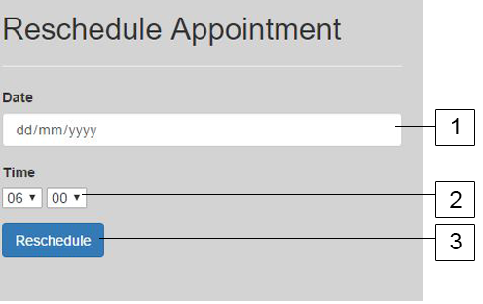

Figure 13 - Reschedule Appointment Box

1. Date must be formatted as “2017-01-28” and cannot be in the past.
2. Enter the time, left box is hours, right box is minutes.
3. Hit the “Reschedule” button to reschedule that appointment.

# Unique Consultant Functionality

This section will only be useful for users that are given consultant privileges. All functionality in this section will be after you have logged onto the system. If you are unsure on how to do this please refer to the start of the manual, “Logging In” section specifically.

## Declaring / Updating your Specialisation

On the first-time logging into your profile you will be greeted with a message asking you to declare your specialisation. This is not necessary but will help with Admin of the system.

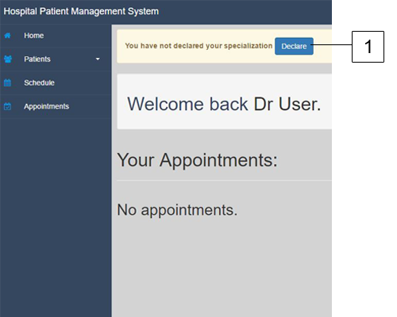

Figure 14 - Declare Specialisation

1. Click the declare button to be brought to the declare specialisation page.

After you enter your specialisation the first time if you need to update it in the future you can click the update button on your homepage.

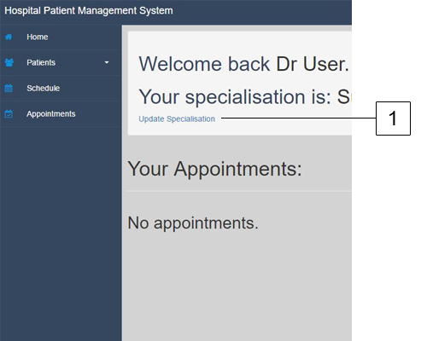

Figure 15 - Update Specialisation

1. Click “Update Specialisation” to be brought to a page to update your specialisation.

## Adding a Prescription to a Patient

To add a prescription to a specific patient first go to the profile of the patient you would like to add a prescription to. If you do not know how to do this look at the “View Patients in System” section of this manual.

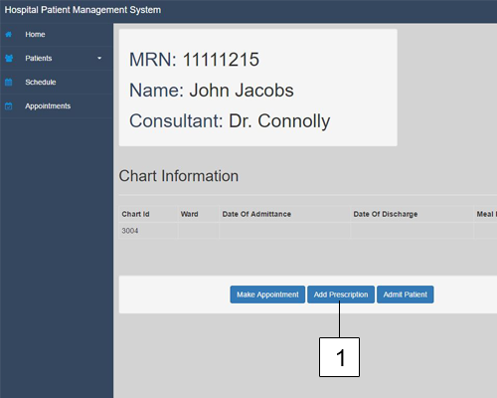

Figure 16 - Adding Prescription

1. Click on the “Add Prescription” button on the patient’s profile page.

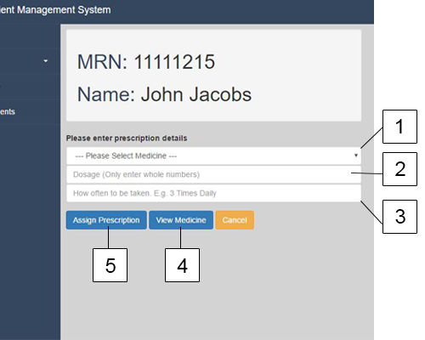

Figure 17 - Adding Prescription Page

1. Select medication from a dropdown menu.
2. Enter the dosage of the medication.
3. How often the medication is supposed to be taken.
4. Detailed full list of all the medications in the hospital.
5. Click “Assign Prescription” once all fields have been filled in.

## Removing a Prescription from a Patient

Once a patient has been prescribed a medication it will appear on their profile page under the “Medication Information” section. To remove the medication simply click on the red trash bin and click ok on the prompt to remove the prescription from the patient.

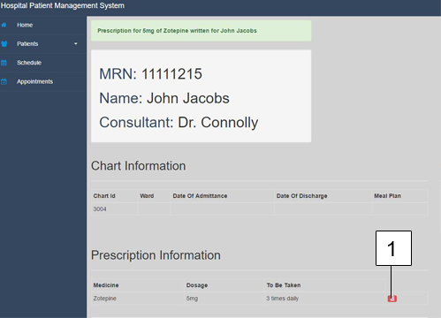

Figure 18 - Removing a Prescription

1. Click on the red trash bin and accept the prompt to remove the medication.

## Admitting a Patient to a Ward

To admit a patient to the ward first navigate to the profile of the patient you would like to admit. If you are unsure on how to find look at the “View Patients in the System” section of this manual.

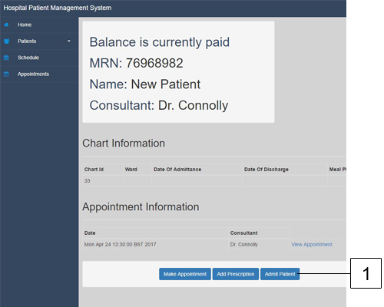

Figure 19 - Admit Patient Button

1. Click on the Admit Patient button on the patient’s profile.

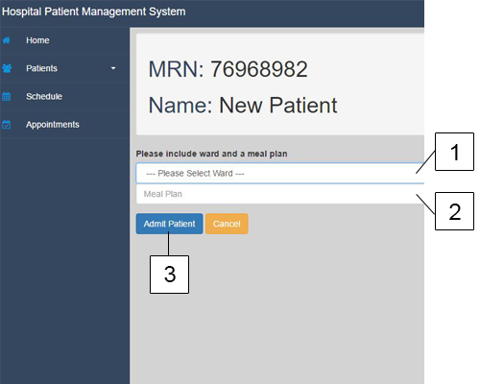

Figure 20 - Admit Patient Page

1. Select a medical ward from the dropdown menu.
2. Enter the meal plan for the patient. E.g. Only Solids
3. Click “Admit Patient” once all fields have been filled.

## Discharging a Patient

Once the patient has been admitted to a medical ward the option to discharge the patient will become available. This can be done through the patient profile page.

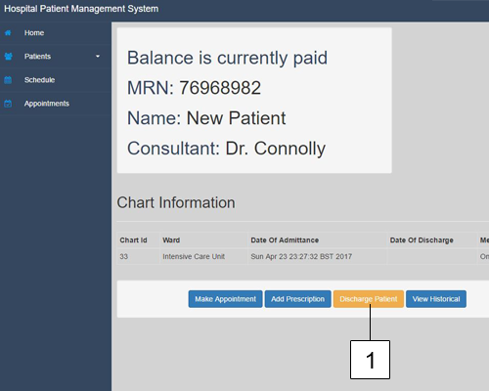

Figure 21 - Discharging a Patient

1. Click on “Discharge Patient” button on the patient profile page.

Once the next page loads click “Confirm Discharge” to discharge the patient from the Hospital.

## Completing / Cancelling Appointments

Once an appointment has been completed or the appointment needs to be cancelled a consultant can confirm this by going into the appointment page. If you do not know how to do this view the “Viewing an Appointment” section of this manual.

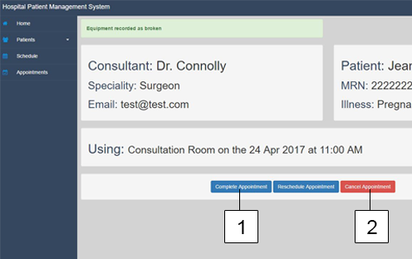

Figure 22 - Completing/Cancelling Appointment

1. Click the “Complete Assignment” to complete.
2. Click “Cancel Appointment” and confirm the prompt to cancel.

## View Historical Appointments

Once an appointment has been completed the only place it can be viewed is in the specific patients profile page. If you do not know how to get to a patient’s profile page view the “View Patients in the System” section of the manual.

Once there click on the “View Historical” button to be brought to a history of that patient’s appointments.

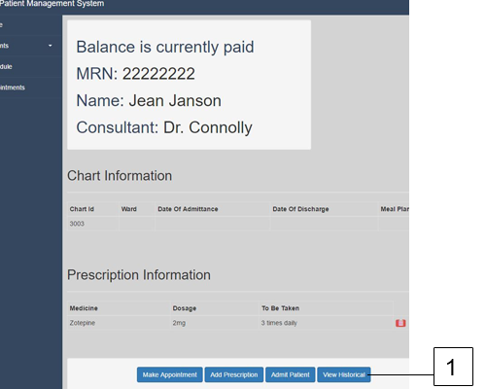

Figure 23 - View Historical Appointments

1. Click the “View Historical” button to be brought to the patient’s previous appointment information.

# Unique Admin Functionality

This section of the manual is for users who have Admin level privileges assigned to them by the Chief Admin of the system. It will cover all the unique functionality that an Admin can do in the system.

## Viewing the Activity Log

All activity on the system is logged in a text file that can be accessed by the admins of the system. It is split up into two sections. Today’s log entries which can be viewed on the admin homepage.

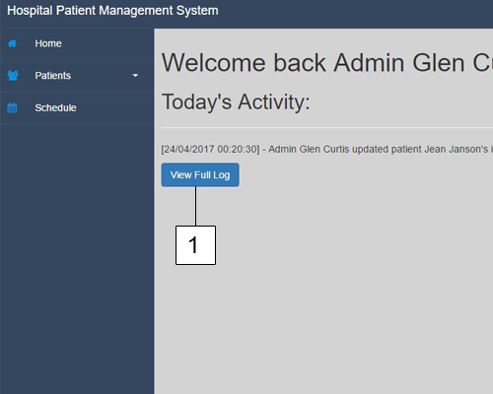

Figure 24 - View Full Log

1. Clicking on “View Full Log” will bring up the entire log.

## Edit Patient Information

If patient information needs to be changed or it was entered incorrectly an admin can do this by going to the view patient section of the website. If you are unsure on how to do this visit the “View Patients in the System” section of this manual.

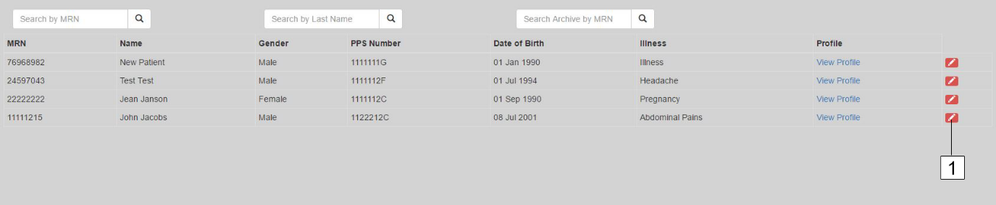

Figure 25 - Edit Patient Information

1. Clicking on the pencil button beside a patient will allow you to edit that specific patient.

This will bring you to the page like one for adding a patient but all the patient’s information will be there to edit however you want. Once finished editing click the “Update Patient” button to submit the changes

## Generate / Pay Patient Bill

These two options can be found on the patient profile page. If you are unsure on how to get here please view the “Viewing a Patient in the System” section of the manual. Once on the page two options will be available. “Pay Bill” and “Generate Bill”.

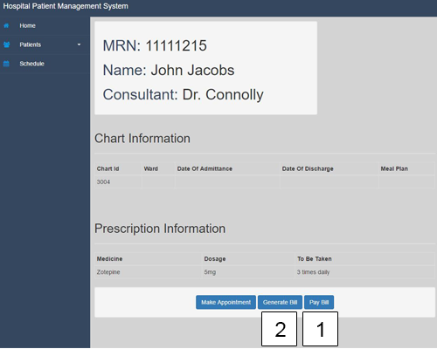

Figure 26 - Generate / Pay Bill

1. When payment is received by the patient for all the expenses they have accrued a admin can confirm this by selecting the “Pay Bill” option. (Note there is no payment functionality in the site. This is purely for management purposes)
2. Generate Bill will create a PDF document in the public folder of the application which will be named after the patients MRN. This can be used to send to the patient after their hospital stay.

## Remove a Consultant from a Patient

If a consultant needs to no longer be linked with a patient or if an appointment needs to be made with another consultant a Admin can remove a consultant by navigating to the patient main profile page. If you are unsure on how to do this view the “Viewing a Patient in the System” section of this manual.

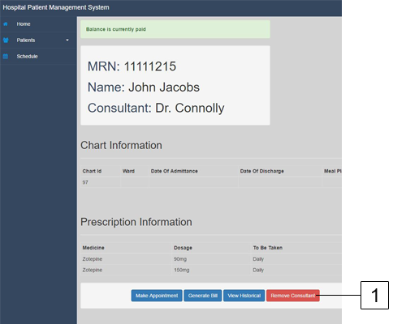

Figure - Removing Consultant From Patient

1. Click the “Remove Consultant” button to remove the consultant from the patient.

# Chief Admin Unique Functionality

The Chief Admin login credentials will be provided by C&C HPMS system designers when the system is first implemented into the hospital. There will be only one log-in and this login will have access to all the background functionality in the hospital.

## Adding a New User

To add a user to the system, navigate to the view users page. This can be accessed from the navigation bar on the left-hand side of the screen.

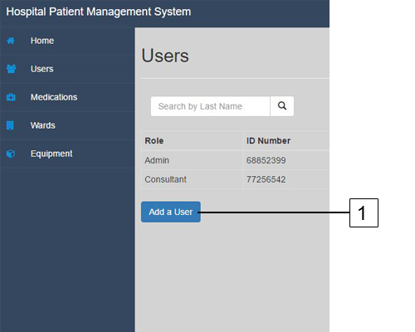

Figure - Add New User

1. Select the “Add a User” button to be brought to the add new user page.

Once you are on the add a new user page simply fill out each one of the form fields. Being sure to take note that;

* Date of Birth needs to be formatted as “YYYY-MM-DD” E.g. 1994-04-07
* PPS Number needs to be 8-9 digits and ending in a letter.
* Email must be unique as this is what they will use to log into the system.
* Correct role must be selected whether they are an Admin or a Consultant.
* Password must be longer than 6 characters.

## Editing a User

If user information is entered incorrectly or needs to be updated this can be done on the view user page accessible by clicking the “Users” tab in the left side navigation bar. Once there;

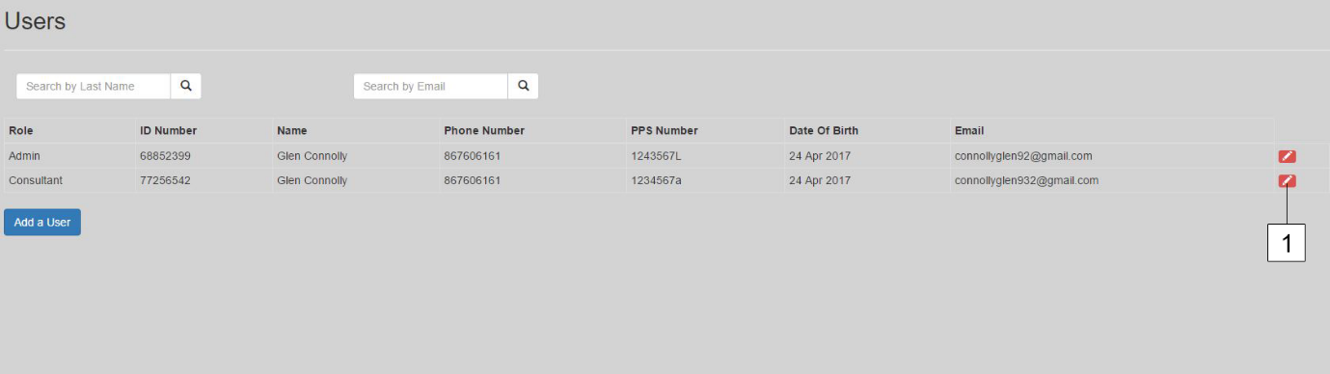

Figure - Editing User

1. Click the pencil icon next to the user you would like to edit to be brought to the Update User page.

Like the page for adding a new user you can update information here and once finished click the “Update User” button. If a user forgets there password simply click the “Change Password” button on the same page and enter in the new password there.

## Adding new Medication

If a new medicine arrives at the hospital it should be entered into the system so Consultants can prescribe it to their patients. To add a new medication simply click on the “Medications” button on the left side navigation bar. Once there;

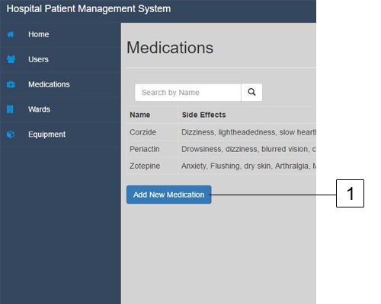

Figure - Add New Medication

1. Click “Add New Medication” button to be brought to the add new medication page.

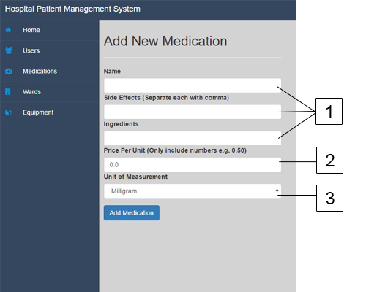

Figure - Add New Medication Form

1. Enter Name, Side Effects and Ingredients in fields.
2. Enter the price per unit of medication. Number will be in euros when medication is entered.
3. Enter the Unit of Measurement from the dropdown box.

Once all fields have been entered hit the “Add Medication” button to add the medication.

## Editing / Deleting Medication

Medication can be edited and deleted on the same page. To do this go to the view medication page by clicking on the “Medications” button on the left side navigation bar. Once there;

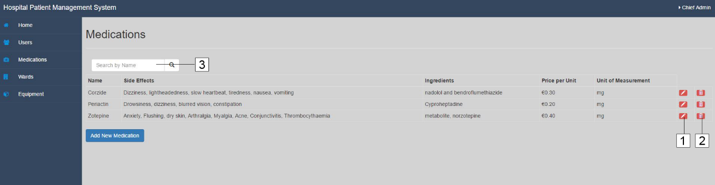

Figure - Editing Medication

1. Click on the red pencil button to be brought to the update medication page. Once there change any of the fields and hit “Update Medication” when finished.
2. To delete the medication hit the red trash bin button to delete the medication from the system.
3. To search for a specific medication type it into the search box and click on the magnifying glass to search.

## Adding a New Ward

If a new ward is built into the hospital it can be entered into the system through the view ward page. To access this page, click on the “Wards” button on the left side navigation bar. Once there;

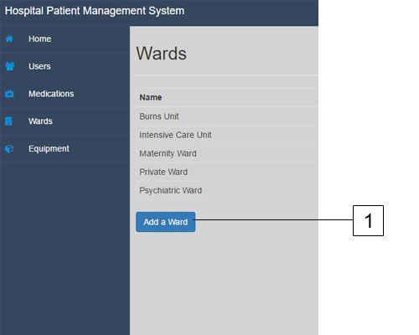

Figure - Add New Ward

1. Click on the “Add a Ward” button

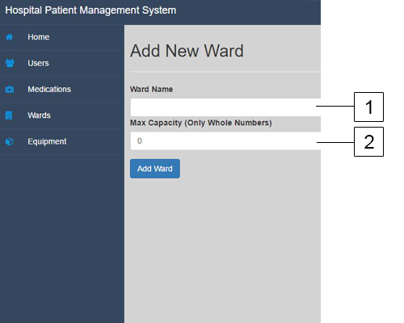

Figure - Add New Ward Form

1. Enter the name of the ward into the text box.
2. Enter the max capacity of the ward. Note this has to be a whole number and contain no letters.

## Editing a Ward

If a ward name needs to be edited or the capacity of the ward needs to be changed this can be done through the view ward page which can be accessed through the “Wards” button in the left side navigation bar. Once there;

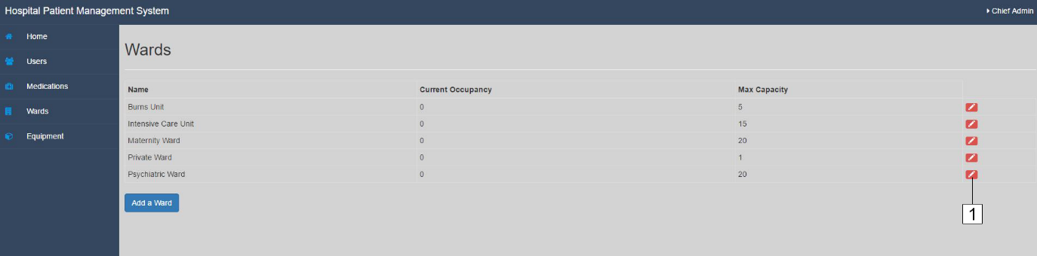

Figure - Editing a Ward

1. Click on the pencil button next to the ward you would like to edit

Once on the page you can change the ward name and edit the max capacity of the ward. Note: the max capacity cannot be lower than the current occupancy.

## Add New Equipment

If the hospital receives new equipment it should be entered into the system. This can be done through the equipment page which can be accessed on the left side navigation bar.

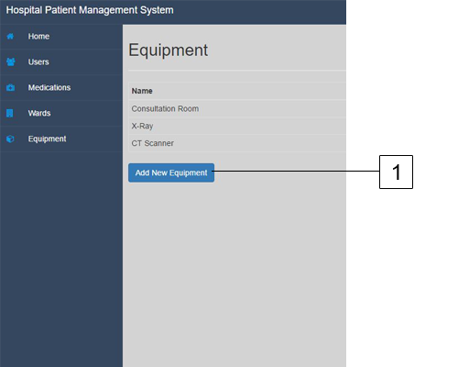

Figure - Add New Equipment

1. Clicking the “Add New Equipment” button will bring you to the add new equipment page.

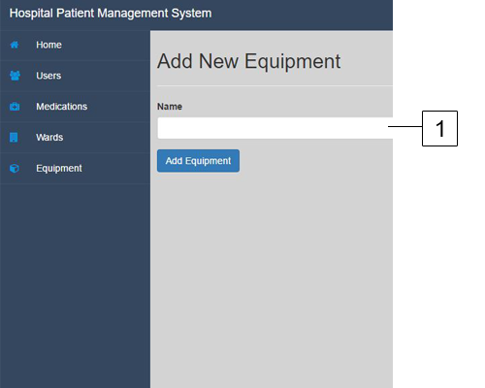

Figure - Add New Equipment Form

1. Enter the name of the equipment in the text box.

Once the name has been entered hit the “Add Equipment” button to enter the new equipment.

## Edit Equipment

If the name of a piece of equipment needs to be changed of the equipment is broken down and cannot be used these can be updated in the view equipment page which can be accessed from the “Equipment” button in the left side navigation bar. Once there;

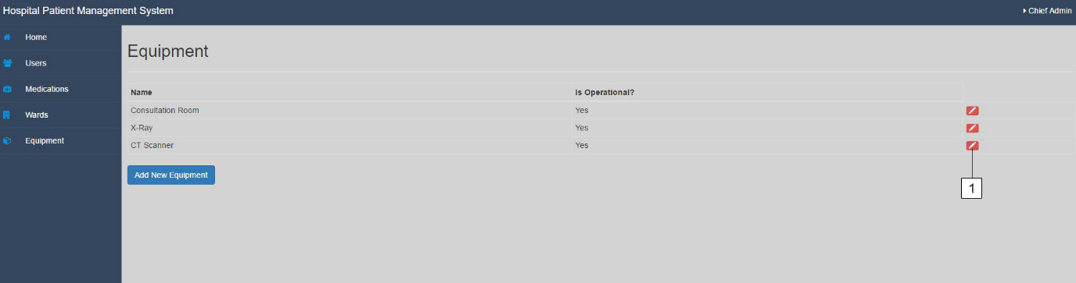

Figure - Edit Equipment

1. Click the pencil button next to the piece of equipment you would like to edit.

Once on the edit equipment page. Change the name of the equipment if needs be or set the equipment to no longer in operation if the equipment is broken down and needs repair. This will mean the equipment can no longer be scheduled for future appointments. Once finishing his the “Update Equipment” button to update.